 | Microsoft Student Ambassadors  Club_KFS  Data Analysis program | 

Smart Decisions with Hotel Booking Analytics
(Teem P06)

Submitted By
0.1 | Rahma Rabee Abd El Moneim
0.2 | Salwa Mohammed
0.3 | Sara Mohammed

Submitted To:
Eng. Alyaa Ebrahim

year
(2025)
Table of Contents
Chapter 1
1.1 Abstract | 4
1.2 Introduction | 4
1.3 Problem Definition | 5
1.4 Objectives | 5
1.5 Tools used: | 5
Chapter 2
2.1 The Methodology of project: | 6
- 2.2Related Works | 7
- 2.3 System analysis and design | 7
2.4 Action Plan | 8
Chapter 3
3.1 Data Preparation and Cleaning: | 9
3.2 Exploratory Data Analysis (EDA): | 13
3.3 Dashboard | 15
3.4 Dashboard Manual | 16

LIST OF FIGURES

Figure 1: ………….………………………………………………………………………………………………….…10
Figure 2:………………………….……………………………………………………………………………………..10
Figure 3 : ……………………………………………………………………………………………………………..12
Figure 4: ……………………………………………………………………………....13
Figure 5: ……………………………………………………………………………....14
Figure 6: …………………………………………………………………………………………………………..……15
Figure 7: ………………………………………………………………………………..19
Figure 8: ……………………………………………………………………………………………………………….20
Figure 9: ……………………………………………………………………………………………………………….26
Figure 10: ………………………………………………………………………………………………………….….34

Chapter 1: Introduction
  - Abstract
This project analyzes a hotel booking dataset to understand booking behavior, cancellations, pricing patterns, and customer characteristics. The data was fully cleaned, including date conversion, feature engineering (total nights, total guests), merging date columns, and removing irrelevant fields. Exploratory Data Analysis (EDA) was conducted using Python (Pandas, Matplotlib, Seaborn) to identify trends and understand correlations between features. The cleaned dataset is ready for generating Pivot Tables and an interactive dashboard, providing insights for data-driven decision-making in hotel management.

  - Introduction

Hotel booking data provides valuable insights for understanding customer behavior, predicting cancellations, improving pricing strategies, and optimizing hotel operations. In this project, a hotel booking dataset was provided for analysis. The main goal was to clean the data, explore it, and extract meaningful insights to support business decisions. The analysis was performed using Python, focusing on data cleaning, exploratory data analysis (EDA), and preparing the data for visualization through Pivot Tables and a dashboard.
1.3 Problem definition of project:
Raw hotel booking data often contains inconsistent entries and irrelevant features, which make it challenging to analyze directly. Key questions include:
- Which hotels have the highest demand?
- What factors influence cancellations?
- Which months or seasons have more bookings?
- How do guest counts and stay durations relate to pricing (ADR)?
The problem is to clean and structure the data, engineer useful features, perform exploratory analysis, and prepare the data for dashboard visualization.
1.4 Objectives of the project:
- The objectives of this project are:
- Clean and preprocess the hotel booking dataset.
- Engineer additional features like total nights and total guests.
- Conduct Exploratory Data Analysis (EDA) to identify patterns and trends.
- Generate meaningful insights to inform business decisions.
- Prepare the dataset for visualization in Pivot Tables and an interactive dashboard.
1.5 Tools used:
- Python (Pandas, Matplotlib, Seaborn)
- Excel
- Jupyter Notebook / VS Code

Chapter 2: projects related works

2.1 The Methodology of project:
The methodology of this project follows a structured data analysis workflow:
Data Collection: The hotel booking dataset was provided in CSV format and loaded into Python using Pandas.
Data Cleaning and Preprocessing: The dataset was inspected for missing values and unnecessary columns. Dates were converted into proper datetime format, and features like total_nights and total_guests were engineered. Irrelevant columns were dropped, and categorical variables were properly defined.
Exploratory Data Analysis (EDA): Visualizations were created using Matplotlib and Seaborn, including histograms, boxplots, scatterplots, countplots, and correlation heatmaps to understand distributions, relationships, and patterns in the data.
Insights Extraction: The analysis identified patterns related to cancellations, booking durations, hotel demand, ADR trends, and guest characteristics.
Dashboard Preparation: The cleaned dataset was exported to Excel to create Pivot Tables and an interactive dashboard for visualization and business reporting.

2.2 Related Works
Previous studies in hotel booking analysis have focused on understanding customer booking behavior, predicting cancellations, and optimizing pricing strategies. Many projects used Python for data cleaning, feature engineering, and EDA, followed by visualization through dashboards. Research shows that dashboards and Pivot Tables help management quickly identify high-demand periods, monitor cancellations, and evaluate revenue per hotel. This project builds upon these concepts by applying similar techniques to the provided dataset and generating actionable insights.

2.3 System analysis and design
The system design focuses on transforming raw hotel booking data into meaningful insights. The analysis system consists of:
Input Layer: CSV dataset containing bookings and customer information.
Processing Layer: Python environment for data cleaning, preprocessing, feature engineering, and EDA.
Output Layer: Cleaned dataset exported to Excel for visualization and dashboard creation.
Visualization: Pivot Tables and interactive dashboards to explore bookings, ADR, cancellations, and guest statistics.
The system ensures that data flows from raw input to actionable insights efficiently and accurately.

2.4 Action plan

The action plan outlines the step-by-step approach to complete the project:

Load the Dataset: Import the CSV file into Python.

Data Cleaning: Convert dates, remove irrelevant columns, and create new features.

EDA and Visualization: Use histograms, boxplots, scatterplots, countplots, and heatmaps to explore the data.

Insight Generation: Identify trends in cancellations, ADR, total nights, total guests, and hotel demand.

Dashboard Creation: Export cleaned data to Excel and create Pivot Tables and interactive dashboards.

Documentation: Prepare the project report including methodology, findings, and conclusions.

Chapter 3: Implementation and coding

3.1 Data Preparation and Cleaning:

Load essential Python libraries:
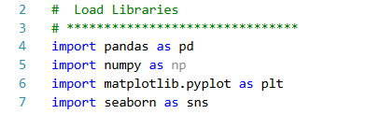
pandas → data manipulation
numpy → numerical operations
matplotlib & seaborn → data visualization

2. Import the CSV file into a pandas DataFrame for analysis.
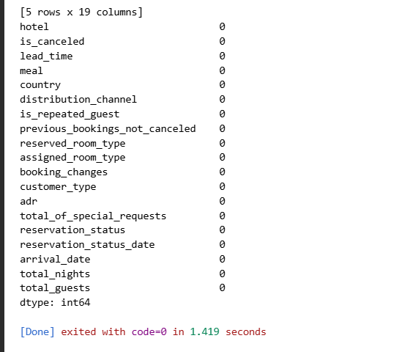

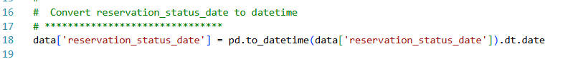
3.Convert the column from object type to datetime type to make it easier to handle.

Map month names to numbers and combine year, month, and day columns to create a full arrival_date column.
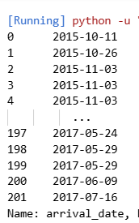
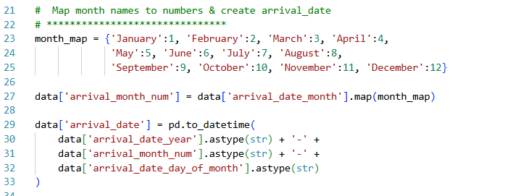

Feature Engineering: total nights & total guests

Create new columns for easier analysis:

total_nights → total nights of stay

total_guests → total number of guests

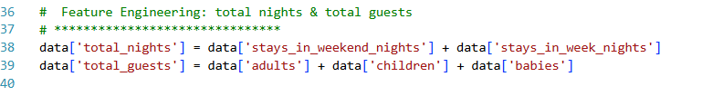

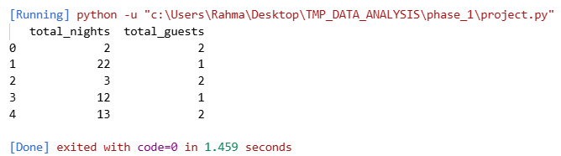

Drop unnecessary columns:
Remove unnecessary or redundant columns after feature engineering.
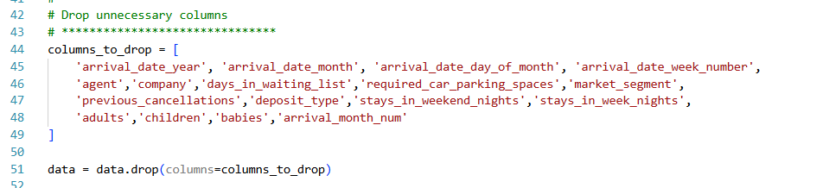
Handle Outliers:
Filter out outliers:
ADR (price) should be >0 and ≤250
Lead Time should be >0 and ≤365
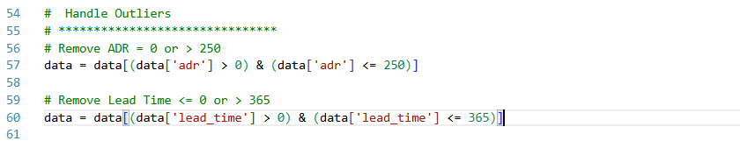
Convert categorical columns to category type
Convert object-type columns to category type to improve analysis performance and memory usage.
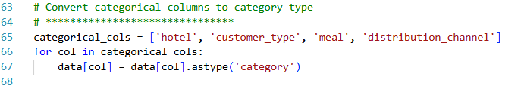

Export final clean dataset
Save the cleaned dataset for later use in Pivot Tables or dashboards.
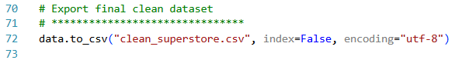

3.2 Exploratory Data Analysis (EDA) :

Gives summary statistics for numeric columns (mean, median, min, max, etc.).

Shows the count of canceled vs non-canceled bookings
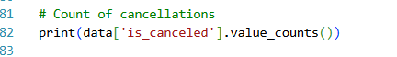

Visualizations
Visualize distributions and relationships between variables.
Identify trends, patterns, and potential outliers.
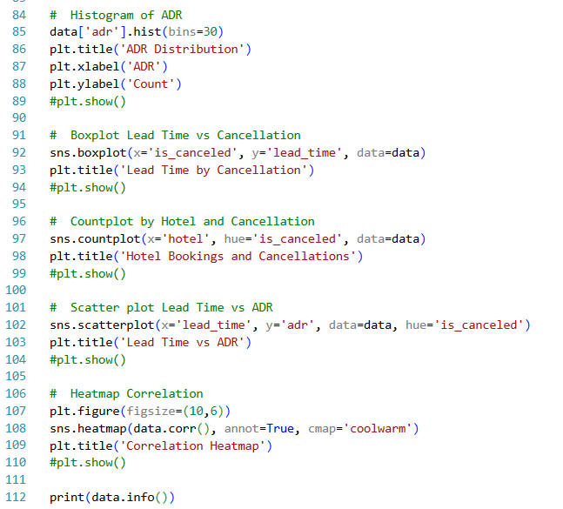

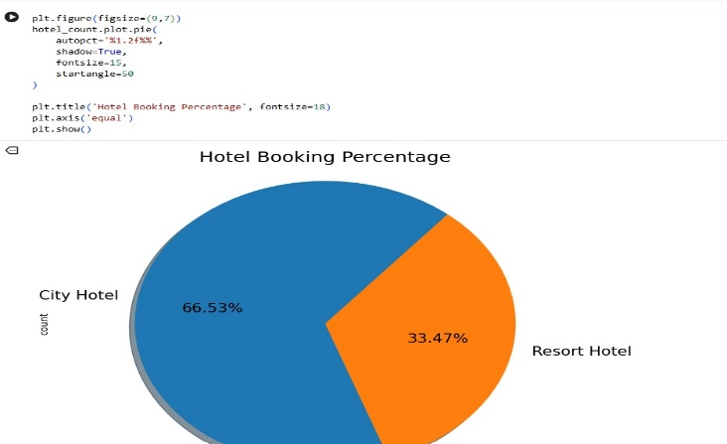
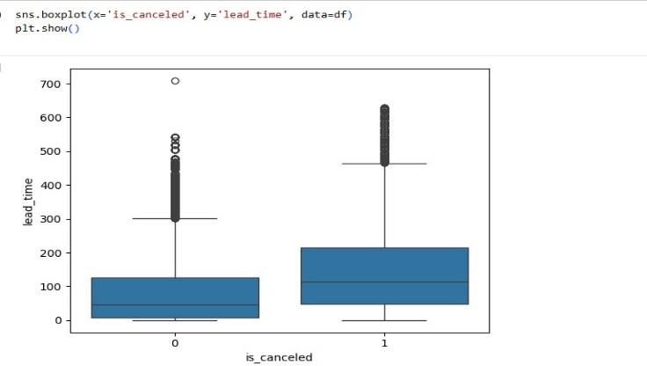
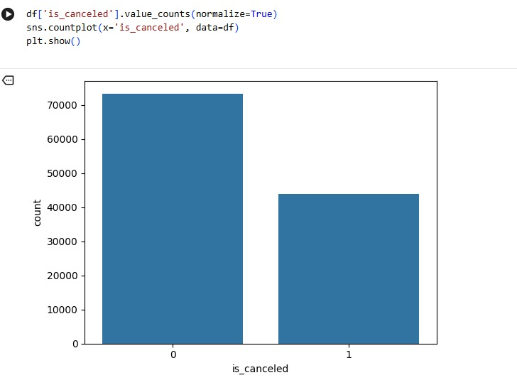
RUN:
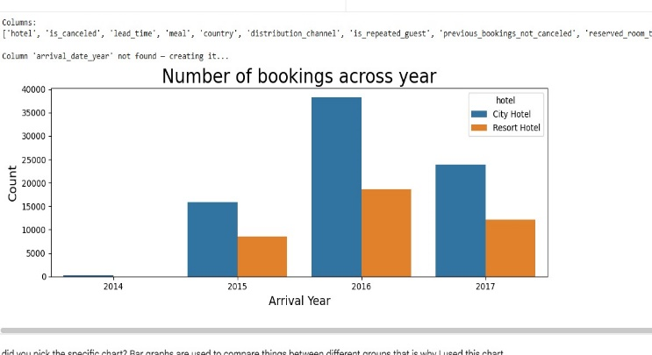
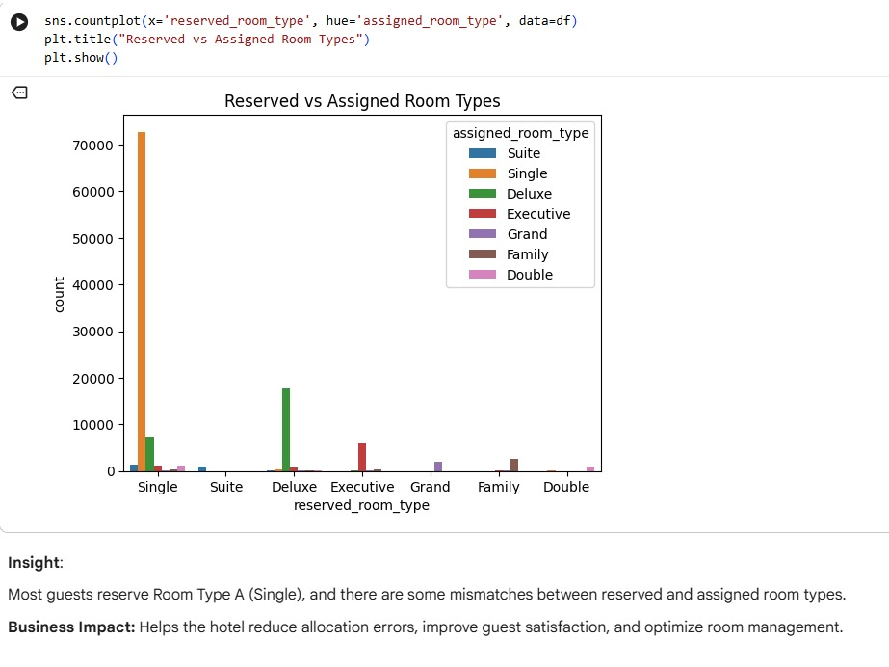
DashBoard :
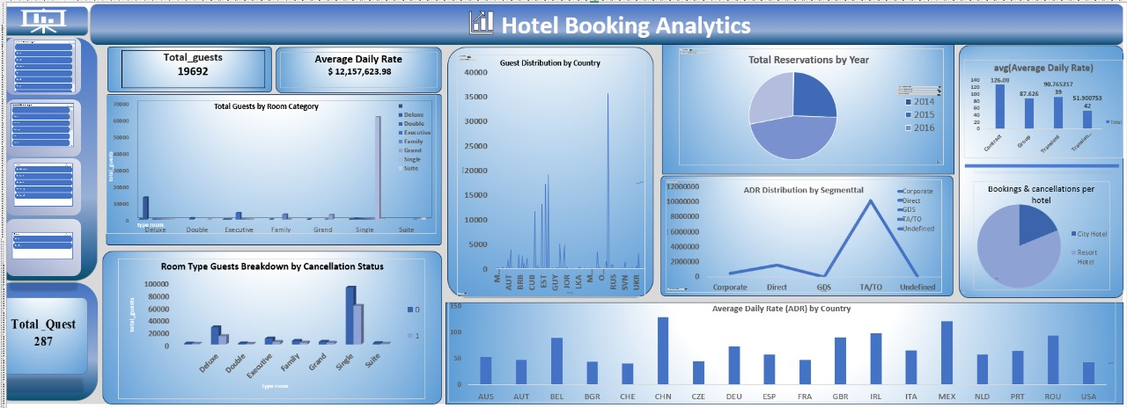

Excel Hotel Booking Dashboard Manual

Purpose
- Monitor hotel bookings in Excel.
- Analyze guests, revenue (ADR), cancellations, and room types.
- Support decision-making using Excel charts and pivot tables.

Dashboard Components in Excel
Key Metrics (Cards / KPI Cells)
- Total Guests
- Average Daily Rate (ADR)
- Total Quest (bookings/inquiries)

Charts (Excel Charts)
- Bar Charts: Guests by room type or country
- Pie Charts : Reservations by year or hotel type
- Line Charts: Revenue trends by segment

Filters / Slicers
Filter data by
Year, Hotel Type, or Guest Segment

How to Use in Excel
- Open the dashboard file.
- Check KPI cells for total guests, ADR, and bookings.
- Interact with Pivot Table slicers to filter data:
- Example: select 2016 to see only that year’s bookings.
- Hover over chart bars for details (Excel shows values).
- Update source data if new bookings are added to refresh charts.

Tips for Analysis
Monitor Single rooms → high cancellations
Focus marketing on top guest countries (China, USA, UK)
Check TA/TO segment** → highest revenue
Compare City Hotel vs Resort Hotelperformance

Technical Notes
All charts are linked to Pivot Tables; do not change source ranges.
Refresh Pivot Tables when data is updated:
Right-click Pivot Table → Refresh
* Use **Slicers** for easy filtering without changing the source.

